Contents
Project Report: E-Commerce Web Application (E-Shop) 1
1. Introduction 1
2. Objectives 1
3. Tools and Technologies Used 2
4. System Architecture & Features 2
4.1. Home Page (Product Listing) 2
4.2. Product Details (See More) 2
4.3. Shopping Cart Management 3
4.4. Contact Page 3
5. Key Implementation Details (Code Snippets) 3
5.1. Fetching Products (API Integration) 3
5.2. Adding to Cart with Duplicate Check 3
5.3. Dynamic Cart Rendering 4
6. Challenges & Solutions 4
7. Conclusion 4
8. References 4

Project Report: E-Commerce Web Application (E-Shop)
Course: AICT Lab
Submitted by: Mohsin Ali Mughal
Student ID: 74669
Date: 01/14/2026
Teacher: Sir kamran

1. Introduction
This project involves the development of a fully functional, responsive E-Commerce application titled "E-Shop by Mohsin.io". The application is designed to simulate an online shopping experience where users can browse products, view detailed specifications, manage a shopping cart, and navigate through a contact interface. The primary goal was to implement modern web technologies to create a dynamic frontend application that interacts with a public API.

2. Objectives
The main objectives of this project were:
- To design a responsive user interface using HTML5 and Bootstrap 5.
- To implement dynamic content rendering using JavaScript and the DummyJSON API.
- To manage application state (shopping cart data) using the browser's Local Storage.
- To create a seamless user experience with features like product filtering, quantity adjustments, and modal alerts.

3. Tools and Technologies Used
The project was built using the following technology stack:
- HTML5: Used for the semantic structure of the web pages (index.html, cart.html, contact.html, seemore.html).
- CSS3: Custom styling using CSS variables for a consistent color theme (Primary: Green #4CAF50, Secondary: Orange #FF9800).
- Bootstrap 5.3: Utilized for responsive grid layouts, navigation bars, carousels, and card components.
- JavaScript (ES6): Handled the logic for fetching data, DOM manipulation, and cart management.
- SweetAlert2: Integrated for aesthetic pop-up alerts when adding items to the cart or deleting them.
- API: Data is fetched dynamically from https://dummyjson.com/products.

4. System Architecture & Features

4.1. Home Page (Product Listing)
The home page features a navigation bar, a promotional carousel using images hosted on lazcdn.com, and a dynamic product grid.
- Functionality: On load, the renderproducts() function fetches product data from the API and maps it to HTML cards.
- Features: Each card displays the product image, title, price, and buttons to "Add to Cart" or "See More".

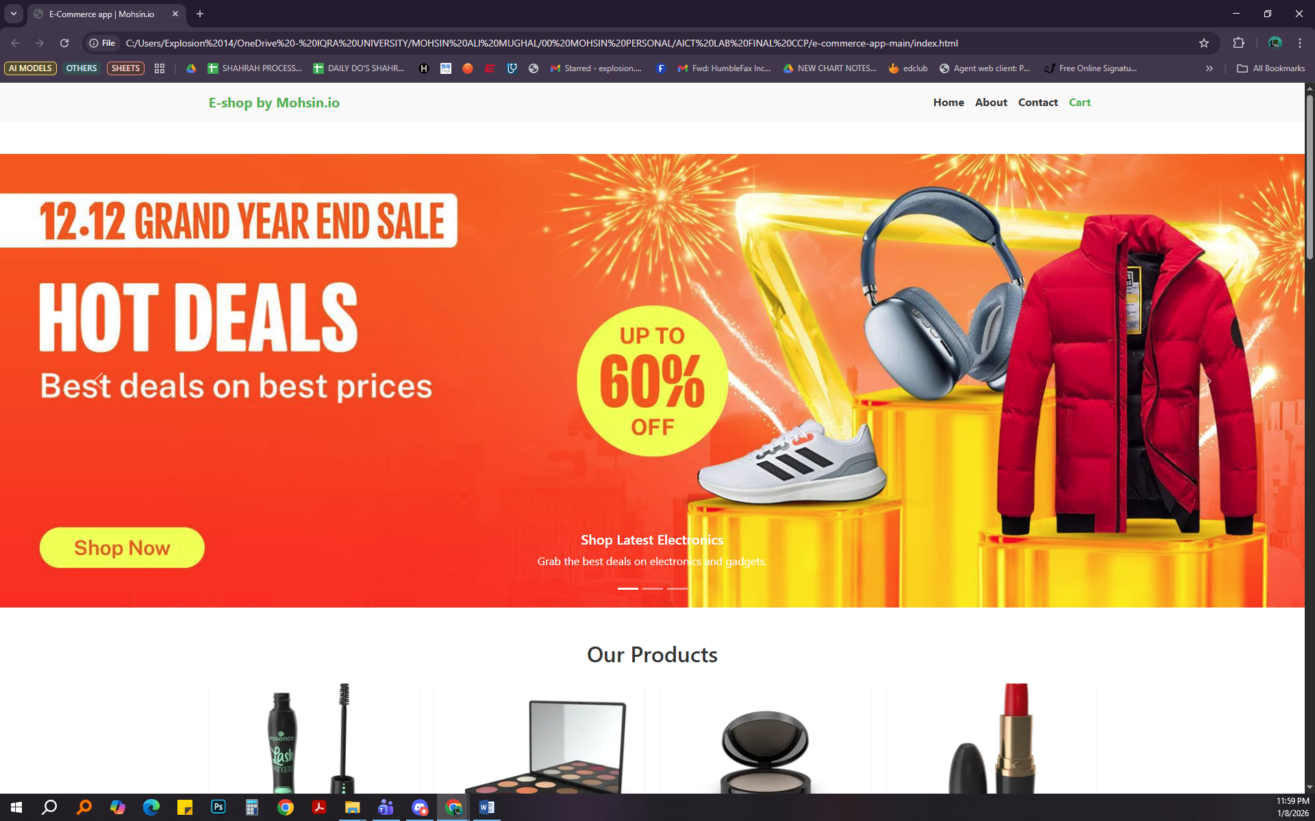

4.2. Product Details (See More)
When a user clicks "See More," they are redirected to seemore.html. The specific product ID is stored in Local Storage to allow the page to fetch and display the correct single product.
- Functionality: The page displays a larger image, description, category, and allows the user to select a quantity before adding to the cart.

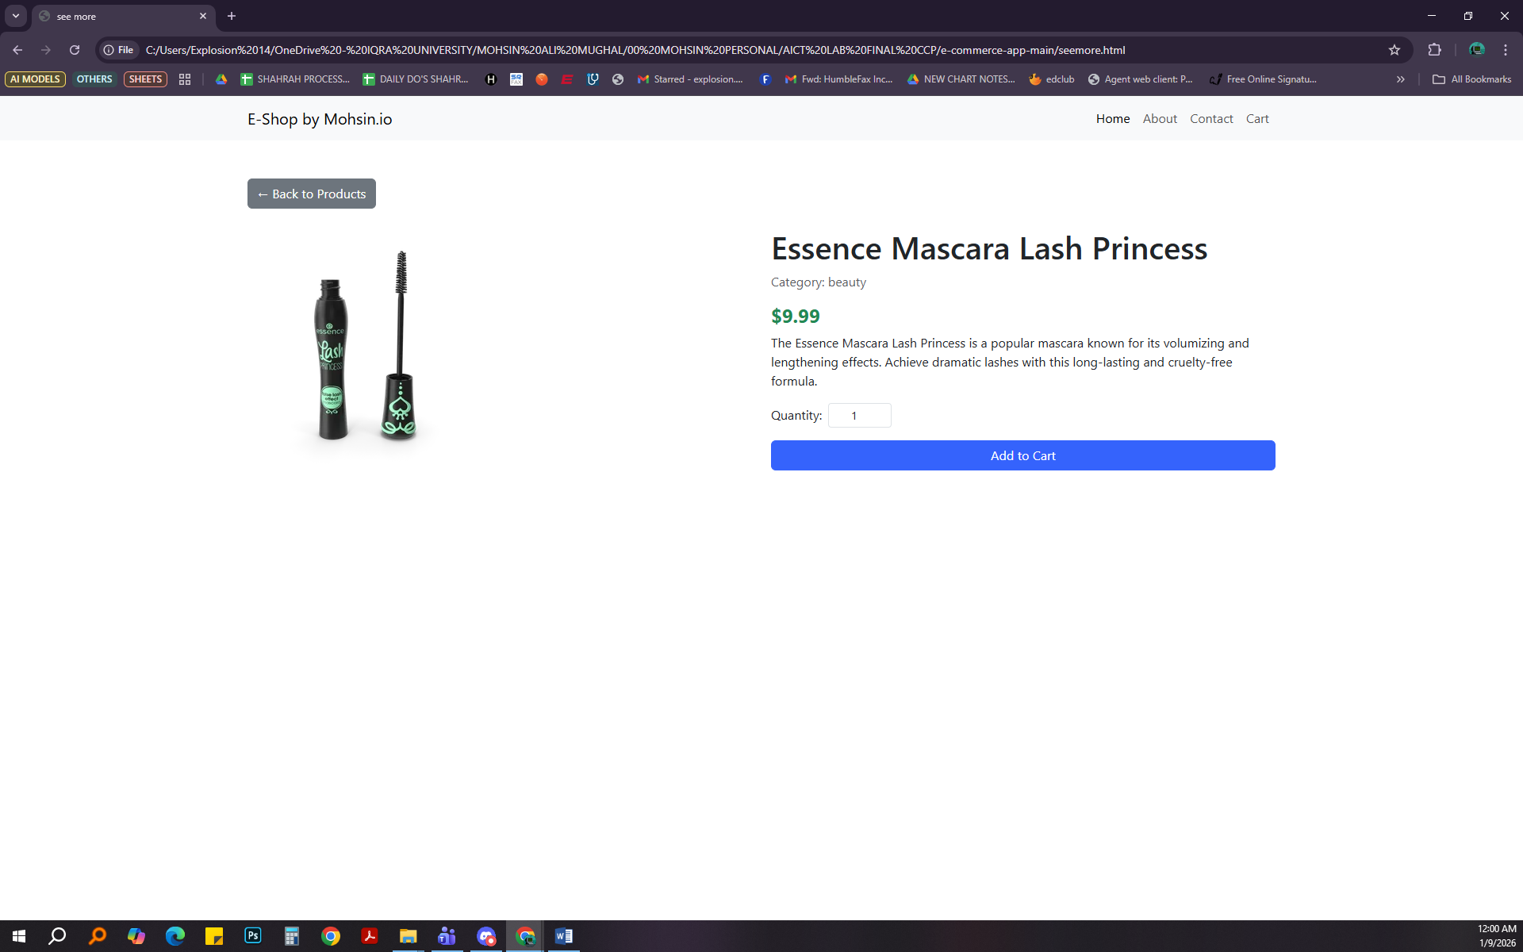

4.3. Shopping Cart Management
The cart system is persistent, meaning data is saved even if the page is refreshed.
- Logic: The cart array is stored in localStorage under the key "cart".
- Operations:
  - Add: Checks if the item exists; if yes, increments quantity; if no, pushes new item.
  - Update: Users can increase (+) or decrease (-) quantities directly in the cart.
  - Remove: Users can delete items, confirmed via a SweetAlert confirmation dialog.
  - Total Calculation: The totalfunc() automatically calculates the sum of price * quantity for all items.

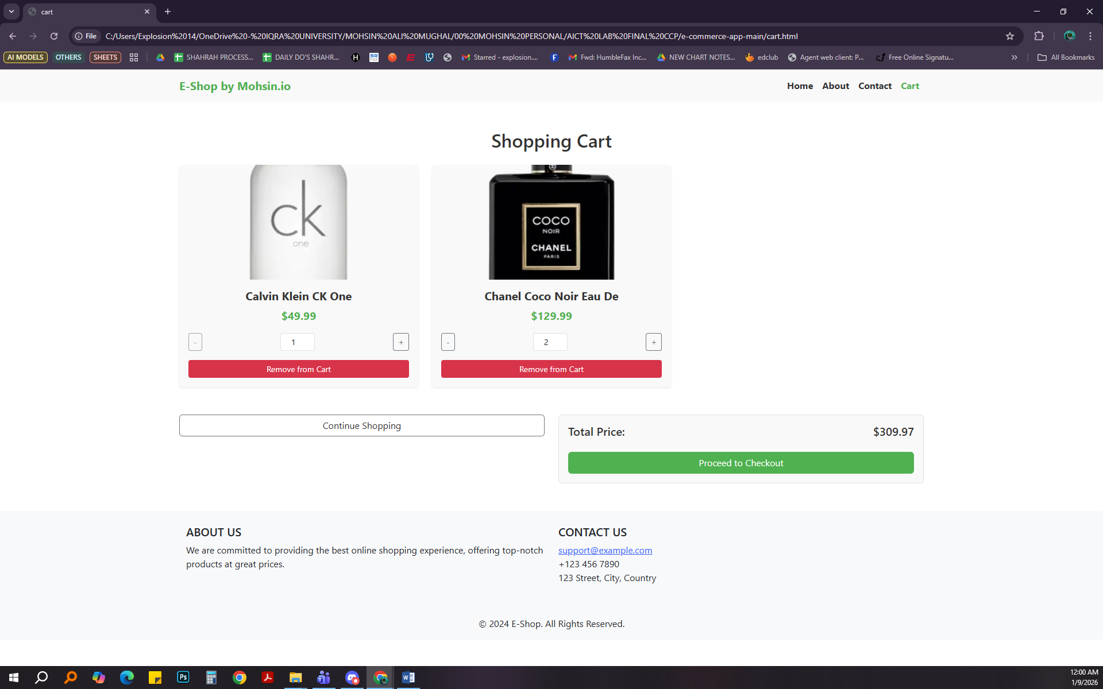

4.4. Contact Page
A dedicated contact page provides a form for users to send messages, alongside static location and contact information styled with Bootstrap Icons.
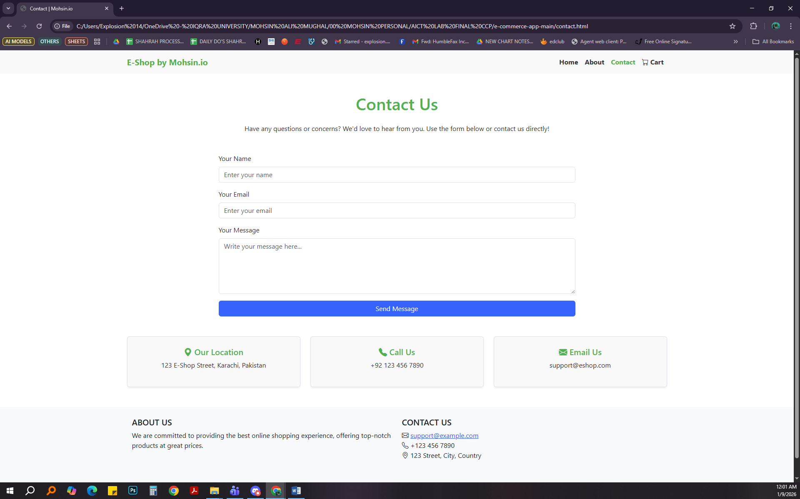

5. Key Implementation Details (Code Snippets)

5.1. Fetching Products (API Integration)
The application uses the fetch API to retrieve product data asynchronously.
JavaScript
// Source: app.js
fetch('https://dummyjson.com/products')
.then(res => res.json())
.then((res) => {
// Mapping products to HTML container
res.products.map((item) => {
productscontainer.innerHTML += `...html code...`
})
})

5.2. Adding to Cart with Duplicate Check
This logic ensures that adding the same item twice increases the quantity rather than creating a duplicate entry.
JavaScript
// Source: app.js
let product = globalcart.find(item => item.id === res.id);
if(!product){
res.quantity = 1

globalcart.push(res) // Add new item
} else {
product.quantity++ // Increment existing
}
localStorage.setItem("cart", JSON.stringify(globalcart))

5.3. Dynamic Cart Rendering
The cart page loops through local storage data to render items and calculates the total dynamically.
JavaScript
// Source: cart.js
const totalfunc = () => {
const cart = JSON.parse(localStorage.getItem("cart")) || [];
const totalPrice = cart.reduce((acc, item) => acc + item.price * item.quantity, 0);
totalprice.innerHTML = `$${totalPrice.toFixed(2)}`;
};

6. Challenges & Solutions
- Challenge: Persisting data between the "Home" page and the "Cart" page.
  - Solution: utilized localStorage.setItem and JSON.stringify to save the cart array as a string, and JSON.parse to retrieve it.
- Challenge: Handling user navigation for specific product details.
  - Solution: Saved the clicked product's ID to local storage (id) before redirecting to seemore.html, allowing the new page to know which product to fetch.

7. Conclusion
The "E-Shop" project successfully demonstrates the application of Information and Communication Technologies (AICT) in web development. By combining a Bootstrap frontend with JavaScript logic and API integration, the result is a functional, user-friendly e-commerce simulation. This project enhanced understanding of DOM manipulation, asynchronous programming, and state management in web browsers.

8. References
- Bootstrap Documentation: v5.3 Framework.
- DummyJSON: https://dummyjson.com/products (Product Data Source).
- SweetAlert2: JavaScript popup library.
- Google Fonts / Bootstrap Icons: Used for typography and iconography.

9. Live Vercel Link

https://aict-lab-ccp.vercel.app/

